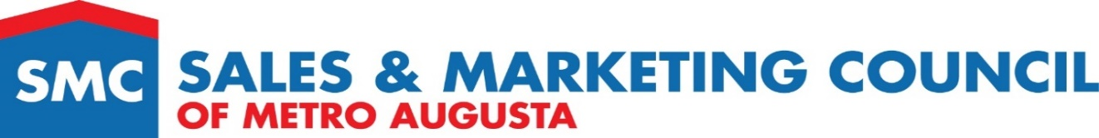

Form 17 Best Website for a Community

Award Criteria

One over all award will be presented to the community judged to have the best website for a community. The community must have had new home sales in 2022.

Judging Criteria

Entry will be judged on graphics, concept, overall design, user-friendly execution, and message communicated to the target market. Judges will view the website online.

Applicant Information

Community Name ___________________________________________________________________

Company Name ____________________________________________________________________

Community Website Address _________________________________________________________

Entry Checklist

________ | Picture of Community
________ | Community Logo

Submitted by (print & sign)

Contact number ________________________________________________________________________

