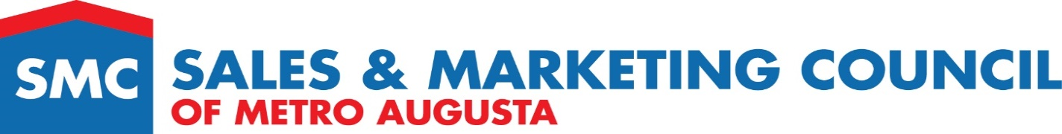
Insert Logo Here

Form 15 Best Curb Appeal for a Spec home
Award Criteria
Submit statement describing the design objectives and how they were obtained. Entries will be judged on visual appeal, inviting entry, coordination of colors, how well the landscape enhances the architecture, and placement of features such as walkways, retaining walls, etc. The home must be a spec home and listed in MLS in 2022
Judging Criteria
Entries will be judged on curb appeal, overall design, creativity, use of materials, color, aesthetics and how it reflects the image of the community
Applicant Information
Community Name |  | ___________________________________________ MLS #: ________
Community Location |  | ________________________________________________
Company Name |  | ________________________________________________
Entry Checklist
 | Attach description of the design and objectives
 | Photos showing curb appeal
Submitted By __________________________________________________________________
Contact Number _______________________________________________________________

