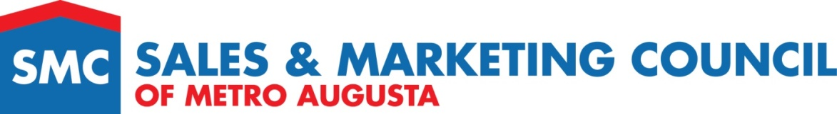

INSTRUCTIONS FOR 2020 Red Carpet STELLAR AWARDS
APRIL 23, 2021

SUBMISSION DEADLINE:
No later than 5 pm on Monday, March 1st.

THE FOLLOWING APPLIES TO ALL SUBMISSONS:
- Forms and other materials must be submitted by EMAIL only to StellarAwards@homebuildersaugusta.org.
- No binders, cd’s, or photos will be accepted.
- Completed form must be submitted along with any additional attachments required.
- All entries must be submitted by a current member in good standing with SMC of Metro Augusta.
- All photos must be of High Resolution.
- Please refer to each form’s individual checklist to ensure you are submitting the required items.
- Missing or incomplete items/forms may disqualify your submission.
- All forms must be signed and approved by the submitter’s broker to ensure accuracy.
- Applicant attests to the accuracy of the information being submitted. The Awards committee reserves the right to request closing statements as necessary. All submissions must have closed in MLS by January 31, 2021 for sales in 2020.

NAMING FILES and PHOTOS
Please name ALL files (forms and other materials) submitted with the Form #, and Name of person applying for the Award. Any revised submissions should state that in the file name.
(EXAMPLE: Form 8-Lucy Smith) or if revised (Form 8 – Revised – Lucy Smith).

FORMS:
Here is the link to all the forms. Copy and paste to browser if the link does not work for you.
http://www.homebuildersaugusta.org/sales-marketing/sales-and-marketing-awards/

If you have any questions, please email one of the members of the
Stellar Awards Committee:

Donatella Armstrong, Chair of SMC donatella.key@southeastern.company

Santalee Jernigan, SMC Board Member sjernigan@meybohm.com

